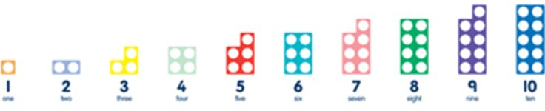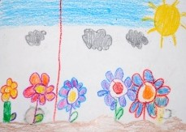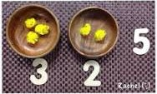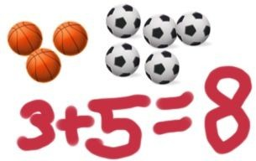Maths for young children should be meaningful. Where possible, concepts should be taught in the context of real life.



Addition

|  |  |
| --- | --- |
| **GUIDANCE / MODELS AND IMAGES** | **KEY VOCABULARY** |
| If available, Numicon shapes are introduced straight away and be used to:   * identify 1 more/less * combine pieces to add * find number bonds * add without counting   Children can record this by printing or drawing around Numicon pieces.  Children can begin to combine groups of objects using concrete apparatus:  +  Construct number sentences verbally or using cards to go with practical activities.    Children are encouraged to read number sentences aloud in different ways “Three add two equals 5” “5 is equal to three and two” “5 is the same as three and two”  Children make a record in pictures, words or symbols of addition activities.  Solve simple problems using fingers  Number tracks can be introduced to count up on and to find one more:  What is 1 more than 4? 1 more than 13?  Number lines can be used alongside number tracks and practical apparatus to solve addition calculations and word problems:  **Children will need opportunities to look at and talk about different models and images as they move between representations.** | Games and songs can be useful way to begin using vocabulary involved in addition i.e.  One elephant went out to play  plus estimate add more and sum total make  altogether score double  one more, two more, ten more… how many more make?  How many more is … than …? same as |

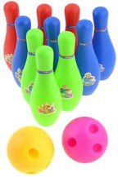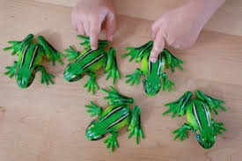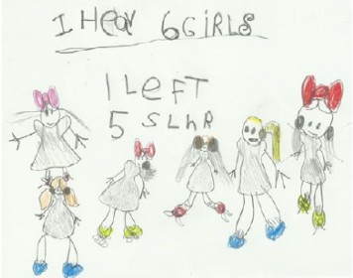

|  |  |
| --- | --- |
| **Subtraction** | |
| **GUIDANCE / MODELS AND IMAGES** | **KEY VOCABULARY** |
| Children begin with mostly pictorial representations or real contexts.  Concrete apparatus is used to relate subtraction to taking away and counting how many objects are left.  Concrete apparatus models the subtraction of 2 objects from a set of 5. | Games and songs can be useful way to begin using vocabulary involved in addition i.e.  Five little men in a flying saucer  take (away) estimate leave |
| Construct number sentences verbally or using cards to go with practical activities. | how many are left / left over? how many have gone/ |
| Children are encouraged to read sentences aloud in different ways “five subtract one  leaves four” “four is equal to five subtract one” “four is the same as five subtract one” | one less, two less, ten less…? |
| Children make a record in pictures, words or symbols of subtraction activities.  Solve simple problems using fingers | how many fewer is …? than…?  difference between the same as  hopping back |
| Number tracks can be introduced to count back and to find one less: What is 1 less than 9? 1 less than 20? |  |
| Number lines can then be used alongside number tracks and practical apparatus to solve subtraction calculations and word problems. Children count back showing hops back on the number line. |  |
| **Children will need opportunities to look at and talk about different models and images as they move between representations.** |  |

|  |  |
| --- | --- |
| **Multiplication** | |
| **GUIDANCE / MODELS AND IMAGES** | **KEY VOCABULARY** |
|  | Lots of |
| The link between addition and multiplication can be introduced through doubling. | Groups of |
| If available, numicon is used to visualise the repeated adding of the same number. These can be drawn around or printed as a way of recording. | Times  Multiply |
| Children being with mostly pictorial representations: | Multiplied by  Multiple of |
|  | Once, twice, three times… ten times… |
| How many groups of 2 are there? *2 + 2 + 2 + 2 + 2, so 5 groups of 2* | … times as (big, long, wide… and so on) |
| Real life contexts and use of practical equipment to count in repeated groups of the same size: | repeated addition  double |
|  | estimate  add again and again |
| How many wheels are there altogether? How much money do I have? |  |
| Count in twos, fives, tens both aloud and with objects. |  |
|  |  |
| Children are given multiplication problems set in a real life context. Child are encouraged to visualise the problem. |  |
| How many fingers on two hands? How many sides on three triangles? How many legs on four ducks? |  |
| **Children are encouraged to read number sentences aloud in different ways “five times two makes ten” “ten is equal to five multiplied by two” “ten is the same as**  **five lots of two”** |  |

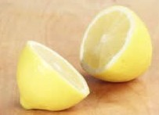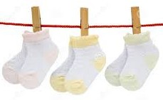

|  |  |
| --- | --- |
| **Division and fractions** | |
| **GUIDANCE / MODELS AND IMAGES** | **KEY VOCABULARY** |
|  | halve |
| The ELG states that children solve problems including doubling, halving and sharing. | share |
| Children need to see and hear representations of division as both grouping and sharing. | share, share equally  one each, two each, three each… |
| Division can be introduced through halving. | groups in pairs, threes… |
| Children begin with mostly pictorial representations linked to real life contexts.  Mum has 6 socks. She grouped them into pairs – how many pairs did she make? How many socks did she have altogether?  Sharing model:  I have 10 sweets. I want to share them with my friend. How many will we have each? | tens equal groups of  divide divided by divided into left, left over  estimate |
| Although not explicit in the development matters document, the sharing model is a useful way of introducing young children to fractions and calculating with fractions. | fraction  half |
| Setting the problems in a real life context and solving them with concrete apparatus will support children’s understanding. | halves  whole |
| “I have got a whole pizza to share between two people. Can you cut the pizza in half?” | quarter |
| Children make a record in pictures, words or symbols of division activities. |  |
| **Children are encouraged to have a go at recording the calculation which has been carried out.** |  |