[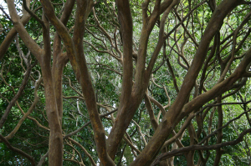](http://zemirahj.files.wordpress.com/2011/04/img_3055.jpg)Treehouse Relaxation Script

This relaxation script is related to finding a peaceful place.  Activities that support children finding a peaceful place help them to feel safe and re-establish feelings of tranquility when they are experiencing challenging emotions.  Next time your child is experiencing stress, worry, tension or other unwanted emotion, read this relaxation script to help him to calm down. Happy Climbing!

**Treehouse Relaxation Script**

1.  Get your body comfortable and gently close your eyes.  
2.  Slowly take three deep breaths, in through your nose and our through your mouth.  
3.  Spend a moment or two, relaxing your feet and legs.  Letting go of any tightness and letting them become heavy and relaxed.  Imagine a wave of blue light traveling up from the earth into your feet and legs, relaxing everything it touches.  
4.  Now relax your tummy, chest, and shoulders.  Imagine this wave of blue light sweeping through and relaxing this area for you.  
5.  Pay attention to your arms and fingers, allow the blue light to move through.  Feel how relaxed you are.  
6.  Finally bring the blue light to your head and allow it to flow out of the top of your head and into the air around you.  Beautifully done!  
7. Imagine you are standing in front of a massive tree.  This tree has deep, deep roots and branches that reach out in every direction.  
8.  This tree is home to your very own treehouse.  This is a treehouse of your own design.  Picture how you would like your treehouse to look.  
9.  (Pause between each idea) You can add swings, windows, trapdoors, plants, animals, your favorite things, your favorite colors, just allow yourself to design the treehouse anyway you like.  
10. Can you see it?  Good.  Now allow yourself to travel inside the treehouse. (Pause) Are you inside?  Good.  
11.  Inside the treehouse, imagine anything that makes you feel good to think about.  Place pillows, waterfalls, plants, trees, birds, pictures of mountains, anything that you would like that you feel good when you think about it.  Go ahead and design the inside of your treehouse now.  
12.  Know that when you go inside your treehouse you feel really really relaxed.  This is a place to let go of all your thoughts, all your worries.  
13.  Take a deep breath and allow yourself to feel very peaceful and relaxed inside your treehouse.  
14.  This is a place that you can go any time you would like to feel more peaceful and calm.  Know that your treehouse is available to you any time you would like.  You can visit here whenever you would like.  
15.  Now take a deep breath and imagine yourself walking down out of your treehouse.  Gently bring your attention back to the room.  
16.  Rub your hands together to make them warm.  Gently place them over your eyes.  
17.  You can open your eyes whenever you are ready.

**Focusing On the Colors You See**

 By inviting children to pay greater attention to the colors they see, we enhance their ability to mindfully observe the world around them. This is a simple mindfulness script for kids that can be explored as an introductory practice.

Wherever you decide to do this practice, set aside 10 minutes to dedicate yourself to it.

Arrive in the present moment.

Take a few mindful breaths, feel the body where it is, and allow your energy to settle.

Pick one color to focus on.

You may try starting with red one day, and work your way through the traditional rainbow spectrum on each subsequent day.

Find one thing you can see that is the color you have picked.

Look at it with beginner’s mind, as if you have never seen this thing before.

Note what it is and its size and shape.

After a few moments, look for something else that is this color.

Observe this object in the same way.

Continuing with this practice, notice when your mind wanders off.

You can always return to the sensation of breathing, using the breath as the anchor for your awareness.  
  
You may find it helpful to mentally note exactly what you are seeing.

For example, a red stop sign doesn’t get labeled “red stop sign”; it becomes “red, octagon, writing, metal.”

When 10 minutes have passed, allow the eyes to close for a moment.

Take a few deep breaths, let go of the practice, and return to your daily life

# **Imagining Your Inner Land To Build Healthy Boundaries**

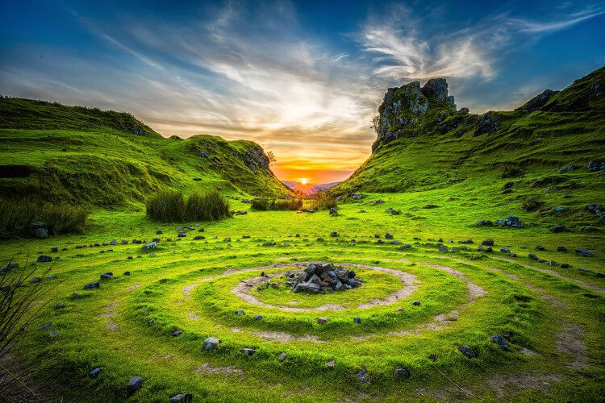This script explores the idea of creating healthy boundaries and nourishing oneself through a garden visualization. This may be more beneficial for older children, though it can be practiced with younger kids with a longer attention span.

Let's begin as we always by breathing together.

Take 5 deep breaths now with me to oxygenate your body, and all of its systems.

As you feel the weight of your body and how it presses down, make sure that your spine is completely straight, and your posture exudes that you are confident.

Gently close your eyes increasing your ability to focus.

As you breathe easily and gently you feel safe and relaxed, my voice guiding you is like a beacon of light through the darkness.

As the sun rises you see you are standing in beautiful lush green grass and there is a small house that you've built by hand in the middle of it.

This house represents you and all the work that you put into yourself and the grass represents the world outside of you.

You decide that it would be good to plant some trees and some shrubs so that these plants will aid in protecting you from harm, and they also benefit the world.

For example, a Raspberry bush is very spiky and dense, yet it gives a bounty of fruits for us to enjoy and be nourished by.

If you plant many in a row, they will protect you as well as a tall electric fence, but this plant also gives.

It serves two purposes.

When you plant tall trees, they will protect you from harsh winds if placed in a way that is good through all of the seasons.

Tall trees supply us with the most oxygen therefore they are giving while also protecting.

The trees also serve many purposes here.

You look at these beautiful life forces that you are planting on your land and you notice they need a water source.

You find the lowest lying area and begin digging down and around making the shape of a small pond.

As you step back from the circle of dirt you've created you know that only a few heavy rains need to pour down and it will begin to fill and turn into a natural source of water.

This pond serves many purposes on your land.

It not only provides you and the wildlife with water, but it also gives you somewhere to go to meditate and reflect on the good things in your life and the good things that you do for others.

Closer to your house you see you need some vegetables and fruits so create a garden that is easy for you to access and water when necessary.

You plant all of the fruits you like and any kind of Vegetables you need.

Your garden flourishes and provides.

All this garden needs from you is to be tended to.

You look around and you see you need an Orchard.

So you strategically plant many apple trees and other fruiting trees, right next to the protected area by the big tall trees and a little closer to the pond so that they can drink.

This Orchard supplies you with the most delicious apples you've ever tasted and their nutrients are off the charts.

You look around your plot of land and you are proud.

Not only do all these plants protect you and your home but they give to you and the community around them.

So make sure you work on the garden within you and put up proper barriers that if planted well and with love and care, they also give.

You are protected and allowed to lead a happy life.

And lastly look again at your hand built home and make any necessary changes to it.

You are an excellent builder, after all.

Good job today.

# **Mindful of your Food and Eating**

This script encourages heightened awareness of one’s experience during a simple bite. Since we don’t often eat in this slow and mindful way, this practice is a powerful application of mindfulness that will spark some interesting conversations around the table.

Eating is an opportunity to nourish your body while nourishing your mindfulness practice.

You can do this practice in any position, but it is helpful to stay still while eating.

This minimizes unnecessary stimulus and helps you focus on the experience.

You can do this with any food. I recommend starting with something simple, like raisins, berries, or a few of your favorite vegetables.

Begin by taking in the food visually. Notice the colors, shapes, and sizes.

As you look at the food, notice the urge to start eating.

There is nothing wrong with hunger, but allow the cravings to come and go.

Return to the sight of the food.

Next, investigate the smell of the food.

Some foods may have stronger aromas than others, and you may have to hold the food up to your nose

Be present for the experience of smelling.

When the mind begins craving, just return to the smell in front of you.

Before eating, take a brief moment to appreciate the energy that went into its production.

People worked to grow this food and bring it to you.

Nature provided nutrients, rainwater, and sunshine.

Maybe somebody cooked, cleaned, or packaged it for you.

Bring into your mind all of the energy from various sources that came together to create this meal.

Now, slowly pick up the food.



If you are using any utensils, tune in to the experience of touch as you feel the utensil.

Mindfully feel how the food or utensil feels in your hand. Is the food stiff, soft, cold, or warm?

As you put the food in your mouth, notice the desire to chew and swallow quickly.

Instead, start by feeling the temperature of the food.

Holding the food in your mouth, can you feel the shape?

As you begin chewing, notice the texture of the food.

Does it change as you continue to chew?

Notice the flavors.

You may have a hard time doing more than simply labeling what you’re eating, such as “It’s a raspberry.”

Try to dig a little deeper. Are there multiple flavors present?

Pay attention to the changing of flavors as you continue to chew.

When you swallow your bite, tune in to the experience of swallowing.

What does it feel like as the food moves down the throat?

You may also notice the desire to quickly have another bite.

Pause and notice if any flavor remains in the mouth for a moment.

You can continue eating like this, reminding yourself to slow down and be present.

Continue to check in with the sights, smells, tastes, feelings, and thoughts that arise.

When you finish eating, allow yourself to feel gratitude for the food that is nourishing your body.

Let the mind relax into a state of appreciation for the energy and life.

# Visualizing Your Peaceful and Beautiful Place**Visualizing your Peaceful and Beautiful Place**

This is a guided meditation script that takes you to your special peaceful & calming place to enjoy & relax.

Take a moment to sit back and relax.

Gently close your eyes  
and breathe deeply into your abdomen.

Feel yourself in your body,  
right now in this moment.

As you breathe,  
allow your body to  
completely and fully relax.

Stress is flowing out of you  
with each breath.

Your body is becoming limp  
and comfortable.

Let the tension in your brow go.

Let the tension in your lips go.

Let the tension in your eyes go.

Just relax in the comfortable  
darkness that surrounds you.

Once you feel completely relaxed and centered,  
start to bring yourself to one of your favorite,  
peaceful, beautiful places.

This could be a place you’ve been before  
like a silent redwood grove with cool shade  
and towering ancient trees  
that protect you in their mammoth embrace,  
or a white sand beach where  
the ocean waves gently lap the shore  
and the smell of the sea  
makes you feel at home.

It could be a place built entirely  
in your imagination,  
a lovely, slowly swaying bridge that you stand on,  
watching a babbling brook flow away beneath it,  
or an ancient oak in the autumn,  
something out of an old legend,  
or golden leaves fall around you  
as you sit under the shade  
and watch the golden orange sun  
pass over the horizon into twilight.

Wherever this special,  
peaceful place is for you,  
take some time to imagine it  
as completely as you can all around you.

Once you have your special place in mind,  
bring yourself into the picture.

Imagine that you’re in this  
beautiful place.

Put yourself there.

Take a walk and look at the lovely,  
peaceful, relaxing surroundings.

# **Short Body Scan**

This script is a great exercise to reconnect children with their physical being. It promotes a deepening of self-awareness, inner peace, and calmness.

Let’s begin by taking a moment to allow your body to settle into a comfortable position.

You may close your eyes or keep them slightly open. Willing the spine to lift, the shoulders to soften  
(5 seconds).

Today we will practice a short body scan,  
checking in with our bodies helps to settle the mind  
and to notice what physiological sensations and emotions might be present (2 seconds).

Begin by taking a full breath in and a long breath out (5 seconds).

Now bringing awareness to the top of your body, your head, face, neck, shoulders (3 seconds).

Noticing any sensations, movements, any places of holding (5 seconds).

Now moving down to the arms and the hands (5 seconds).

Sensing the back of the body, the front of the body (3 seconds).

Sensing yourself seated.

Feeling the contact of your body with the chair or the cushion (10 seconds).

Now sensing your upper legs, your lower legs, and the feet (5 seconds).

Noticing if there are any particular places that call out for attention.

Places where sensations feel most vibrant or dynamic (10 seconds).

Scanning to see if there places where there is a lack of sensations or only very faint sensations  
(5 seconds).

Now sensing the whole body breathing (2 seconds).

One complete organism (20 seconds).

Finishing with a full deep breath in (2 seconds)

and a long breath out *ding* (20 seconds).

**Integrated Practice:** Try a 3 Centers practice today.  
Choose a time during your day to take  
three breaths, each breath to ‘scan’ one area of the body.  
1st breath, scan the head, representing thoughts.  
2nd breath, the gut, representing “gut feelings.”  
3rd breath, the heart, representing values or intentions.  
  
**Reflection Question:**  
What information do you receive when checking in with your body?

# **Visualization of a Sleepy Train Ride**

This is a great guided meditation script for relaxing to attain good night's sleep by using a sleepy train ride imagery.

Hello and welcome to this meditation.

I am going to guide you into a restful sleep by taking you on a relaxing train ride through the beautiful countryside.

Find a comfortable position now and make sure that you will not be disturbed so that you get a restful sleep.

Get as comfortable as you can now, and at any time along the way you need to reposition yourself to get even more pleasant sleep, you can do so.

Begin to let go of all the tension you build up throughout the day.

Any worries you accumulated seem to lose their power and intensity as you settle down for the night.

Feeling cozy now, allow your breath to begin to slow down with each breath you take.

A nice full breath in….and slowly exhale.

Letting your breath return to normal now, just observe your mind and how it is thinking of various things about your life and your day.

Observe how perhaps visuals of moments flash in your mind or maybe you feel them, you may be able to hear sounds with your thoughts as they present themselves.

Good.

Pause for 10 seconds

Letting images from your life fade now, bring into your imagination that you are walking towards a long train, that is parked along the countryside.

The Engine of the train is stopped at an old station in the middle of nowhere, and the long train extends into the horizon.

You are walking several sections back, and you notice an open wagon.

You see the workers getting ready to depart, and steam is billowing out from the engine.

You hop on the open wagon and find it is filled with fresh hay.

You hear the train horn blowing, and the sounds of distant voices calling “all aboard”.

You lay down in the hay and it is perfectly comfortable.

You are positioned in a way that you are gazing out the open door into nature.

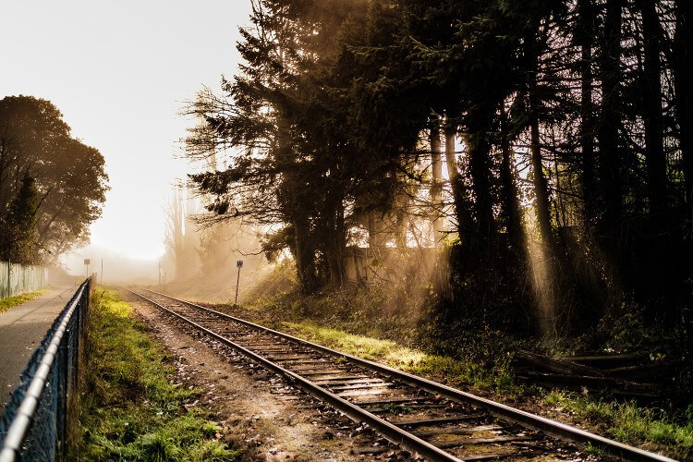

As you sit back, waiting for the train to begin to roll, you look around the wagon and notice all the details.

The weather is perfectly mild, and soothing.

Perhaps you can sense the smell of hay and the countryside breeze.

Notice everything as vividly as you can.

You feel slight vibrations as the train powers up, and you can hear it’s mighty engine hissing as it builds enough power to pull the massive weight.

Soothing station bells begin to ring, alerting that the train is leaving the station.

The wagon begins to roll, very slowly, and you take a deep, breath of relief because you know you are in for a long, relaxing ride.

The vibrations under you get stronger because the train is increasing in speed.

You can hear the relaxing sounds of the wheels turning along the tracks.

The station bells get louder as your wagon passes by this small station in the middle of nowhere, and then they pass by, and the ringing sounds get fainter in the distance until you cannot hear them any longer.

The vibrations under you are strong, yet soothing.

They even out into a relaxing hum, as the train has reached a safe and steady speed for a long journey.

As you gaze outside, it is still light, but it will be sunset very soon.

You can see out both sides of this train car, making for the most beautiful views you have ever seen.

You see the ground close to you passing by very quickly.

And the trees nearby passing a little slower, and in the distance, some rolling mountains are moving by ever so slowly as you ride.

Look out into this nature and just really enjoy its beauty.

Pause for 10 seconds

The sun is beginning to meet the horizon, setting behind a soft, rolling mountain range in the distance.

The colors that this sunset begins to create for you are breathtaking.

The pinks and yellows of the sky fade into the bright blue, then into the deep blue of the night sky inching in.  
  
The gentle mountain range gives off hues of greens and blues, and grays.

The sundown is reflecting colors of purples mixed with oranges now as it dips below the mountains.

Meadows of warm golden colors are passing by the train and every now and then an old giant oak tree passes you by, standing proudly in the sprawling fields of gold.

This view is mesmerizing, and you are not thinking about anything other than the beauty you are witnessing.

You are getting more and more relaxed, and feeling grateful for these beautiful moments in the twilight upon this sleepy train.

You are very comfortable and ready for a restful night’s sleep.

The aura of the sun is slowly fading away, and the night sky is chasing away the sunset.

Your eyes are becoming heavy with sleep, as you watch the day turn to darkness.

The wide meadows have passed by and the train is entering a forest.

The weather cools just a bit and you can smell the trees as they close in around the train.

Dark has settled in yet there is crisp moonlight peeking through the trees as they pass by.

The hum and resonance of the train are very soothing to you, making you even more sleepy.

Your eyes are closed now, and occasionally you open them for just a moment to gaze around the wagon and the view into nature.

Now hear yourself saying, as you drift and float on this dreamy train ride,

“Sleep comes and it restores me and heals me.

Nighttime is my time to fully rest and rejuvenate.

A restful night’s sleep is approaching, and I am just along for the ride

I have done all that I need to do today.

Right now, I don’t have to do anything but sleep.

I breathe peacefully and easily, relaxing my mind and body.

Sleep comes over me naturally, and willingly.

As I become more relaxed and sleepy, this gives my body the time to heal.

I know how good this is for me right now.

Deep and restful sleep is possible every night, when I let go of worries and stress.

My breath is steady and slow, carrying me into a long night’s sleep.

As I become sleepier and sleepier, my brain slows, yet my creativity increases.

This creative state is void of any of my worries or fears.

It is completely open to showing me how to achieve my goals and attain my desires.

I am grateful for my day that was well lived, and now it has become night.

Through sleeping and dreaming, I accomplish great advances in my psyche, which extend into my waking life.

Now it is my time to dream.

I embrace rest as one of nature’s natural healing medicines.

My body feels very heavy and calm.

My muscles are completely relaxed, and any remaining tension completely fades.

My mind is quiet and clear.

I enjoy waking up refreshed and rejuvenated after a marvelous sleep.

I sleep well each and every night.

Nothing disturbs me when I sleep.

The more rest I get, the more excellent tomorrow will be.

I thank my body for allowing this time of rest and relaxation.

I thank my mind for letting go of worries and opening to resourcefulness through dreaming.

No matter how much of my dreams I remember, I know that they are constructive and offer a space for my imagination to flourish.

Dreaming and sleeping allow for great vision and inventiveness to take place in my mind.

I release all my thoughts from the day.

I release any tension I accumulated from the day.

I awaken refreshed and happy when I have gotten the perfect amount of sleep that I need.

I am grateful for my beautiful bed and pillow that support me.

I am calm and full of peace.

Falling asleep is effortless for me.

I know that the words I say and the things I think come into action.

I say with confidence every day that I sleep easily and restfully.

Each night when I lay down on my soft pillow, I am greeted by sleep, and I welcome this sensation.

I sleep so soundly that my body and mind are completely refreshed and ready to accomplish anything.

I look forward to going to bed, knowing it will be quiet and relaxing.

I look forward to doing all the little things I like to do to prepare for getting in the bed.

I turn off all lights before getting in bed because darkness releases melatonin in my body, aiding in perfect rejuvenation.

Falling asleep happens quickly, without any effort.

Good.

Now just drift and float, not thinking about anything in particular.

Just let things come and go as things always do.

Sleep is encompassing you now.

The train is taking you along for the ride and to a new and beautiful destination when you rise.

So enjoy this time, and allow my voice to completely fade away just as the sleepy train rolls along through the wilderness.

Thank you and have a good night.